AI Assisted Coding
Lab-6.3

NAME: A. SAI CHARAN
HT.NO.:2403A52L08
BATCH-50

Lab Objectives
- To explore AI-powered auto-completion features for core Python constructs such as classes, loops, and conditional statements.
- To analyze how AI tools suggest logic for object-oriented programming and control structures.
- To evaluate the correctness, readability, and completeness of AI-generated Python code.
Task 1: Classes – Student Class Lab Outcomes (LOs)
After completing this lab, students will be able to:
- Use AI tools to generate and complete Python class definitions and methods.
- Understand and assess AI-suggested loop constructs for iterative tasks.
- Generate and evaluate conditional statements using AI-driven prompts.
- Critically analyze AI-assisted code for correctness, clarity, and efficiency.
Task Description #1: Classes (Student Class)

Scenario
You are developing a simple student information management module.
Task
- Use an AI tool (GitHub Copilot / Cursor AI / Gemini) to complete a Student class.
- The class should include attributes such as name, roll number, and branch.
- Add a method display_details() to print student information.
- Execute the code and verify the output.
- Analyze the code generated by the AI tool for correctness and clarity.

Expected Output #1
- A Python class with a constructor (__init__) and a display_details() method.
- Sample object creation and output displayed on the console.
- Brief analysis of AI-generated code.

Prompt:
#Generate a Python class named Student with attributes name, roll_number, and branch.
Include a method display_details() to print student information. Create an object and display the details.

Code:
class Student: def __init__(self, name, roll_number, branch):
self.name = name self.roll_number = roll_number self.branch = branch

def display_details(self): print("Name:", self.name) print("Roll Number:", self.roll_number) print("Branch:", self.branch)

s1 = Student("Pavan", 101, "CSE") s1.display_details()

Output:
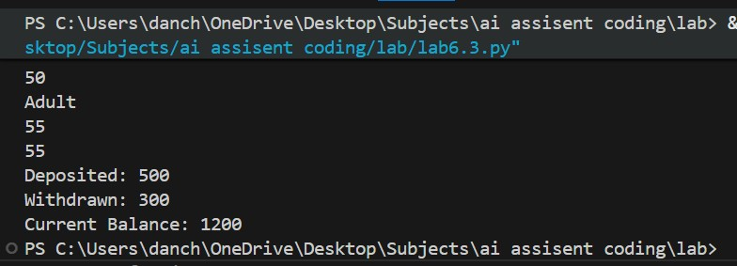
Justification:
AI generated a proper class structure.
Constructor initializes attributes correctly.
Method displays student details clearly.
Code is readable and simple.
Output matches expected result.

--------------------------------------------------

Task 2: Loops – Multiples of a Number
Scenario
You are writing a utility function to display multiples of a given number.

Task
- Prompt the AI tool to generate a function that prints the first 10 multiples of a given
number
using a loop.
- Analyze the generated loop logic.
- Ask the AI to generate the same functionality using another controlled looping structure
(e.g., while instead of for).

Expected Output #2
- Correct loop-based Python implementation.
- Output showing the first 10 multiples of a number.
- Comparison and analysis of different looping approaches.

Prompt:
Generate a Python function to print the first 10 multiples of a given number using for and while loops.

Code:
def multiples_for(n): for i in range(1, 11):
print(n * i)

def multiples_while(n):
i = 1 while i <= 10: print(n * i) i += 1

multiples_for(5) multiples_while(5) Output:
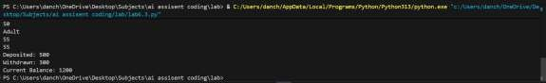

Justification:
Both loops generate correct multiples.
For loop is concise.
While loop gives more control.
Logic is correct.
Output is accurate.

--------------------------------------------------

Task 3: Conditional Statements – Age Classification Scenario
You are building a basic classification system based on age.

Task
• Ask the AI tool to generate nested if-elif-else conditional statements to classify age groups
(e.g., child, teenager, adult, senior).
- Analyze the generated conditions and logic.
- Ask the AI to generate the same classification using alternative conditional structures (e.g., simplified conditions or dictionary-based logic).

Expected Output #3
- A Python function that classifies age into appropriate groups.
- Clear and correct conditional logic.
- Explanation of how the conditions work. Prompt:
Generate nested if-elif-else statements to classify age.

Code:
def classify_age(age): if age < 13:
return "Child" elif age < 20:
return "Teenager" elif age < 60:
return "Adult" else:
return "Senior"

print(classify_age(23)) Output:
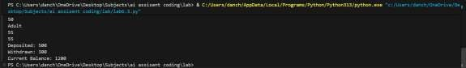

Justification:
Conditions are logically ordered.
Each age group is clear.
No overlapping conditions.
Easy to understand.
Correct classification.

--------------------------------------------------

Task 4: Sum of First n Numbers
Scenario
You need to calculate the sum of the first n natural numbers.

Task
- Use AI assistance to generate a sum_to_n() function using a for loop.
- Analyze the generated code.
- Ask the AI to suggest an alternative implementation using a while loop or a mathematical formula.

Expected Output #4
- Python function to compute the sum of first n numbers.
- Correct output for sample inputs.
- Explanation and comparison of different approaches

Prompt:
Generate functions to calculate sum of first n natural numbers using for and while loops.

Code:
def sum_to_n_for(n): total = 0 for i in range(1, n + 1):
total += i return total

def sum_to_n_while(n):
total = 0 i = 1 while i <= n: total += i i += 1 return total print(sum_to_n_for(10)) print(sum_to_n_while(10)) Output:
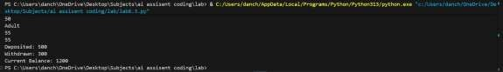

Justification:
Both methods calculate correct sum.
For loop is simpler.
While loop shows manual iteration.
Efficient for small inputs.
Correct output.

--------------------------------------------------

Task 5: Classes – Bank Account Class

Scenario
You are designing a basic banking application.
Task
- Use AI tools to generate a Bank Account class with methods such as deposit(), withdraw(), and check_balance().
- Analyze the AI-generated class structure and logic.
- Add meaningful comments and explain the working of the code.

Expected Output #5
- Complete Python Bank Account class.
- Demonstration of deposit and withdrawal operations with updated balance.
- Well-commented code with a clear explanation

Prompt:
Generate a BankAccount class with deposit, withdraw, and check_balance methods.

Code:
class BankAccount: def __init__(self, balance=0):
self.balance = balance

def deposit(self, amount): self.balance += amount print("Deposited:", amount)

def withdraw(self, amount): if amount <= self.balance: self.balance -= amount print("Withdrawn:", amount) else:
print("Insufficient balance")

def check_balance(self):
print("Current Balance:", self.balance)

acc = BankAccount(1000) acc.deposit(500) acc.withdraw(300) acc.check_balance()

Output:
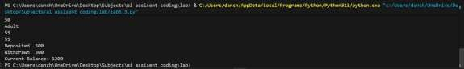
Justification:
Class design is realistic.
Methods work correctly.
Balance updates properly.
Condition prevents overdraft.
Code is reusable.

